**Pizza Sales SQL Queries**

1] Total Revenue :

select SUM(total_price) as Total_Revenue from pizza_sales

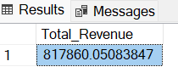

2] Average Order Value : total revenue/total orders :

select sum(total_price)/count(distinct order_id) as Average_Order_value

from pizza_sales

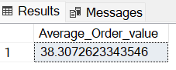

3] Total pizza sold :

select sum(quantity) as Total_pizza_sold from pizza_sales

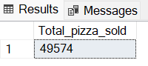

4] Total Orders :

select count(distinct order_id) as Total_orders from pizza_sales

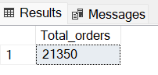

5] Average pizza per order : total_pizza_sold/total_orders :

select sum(quantity)/count(distinct order_id) as Average_pizza_per_order

from pizza_sales

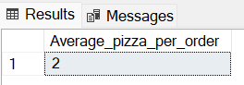

**KIPS**

6] Daily Trend For Total Order :

select DATENAME(DW , order_date) as order_day , count(distinct order_id) as total_order from pizza_sales

group by DATENAME(DW , order_date)

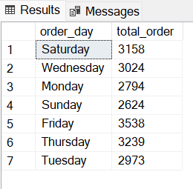

7] Monthly Trend For Total Order :

select DATENAME(MONTH,order_date) as Month_Name, count(distinct order_id) as Total_order from pizza_sales

group by DATENAME(MONTH,order_date)

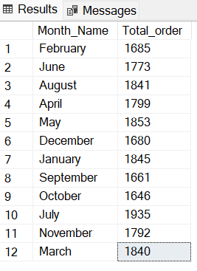

8] Percentage of sales by pizza category :

select pizza_category,cast(sum(total_price)*100 /

(select sum(total_price) from pizza_sales) as decimal(10,2)) as Pecentage_of_sales , cast(sum(total_price) as decimal(10,2)) as Total_sales

from pizza_sales

group by pizza_category

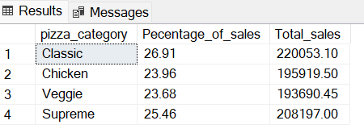

9] Percentage of sales by pizza size :

select pizza_size,cast(sum(total_price)*100 /

(select sum(total_price) from pizza_sales) as decimal(10,2)) as Pecentage_of_sales , cast(sum(total_price) as decimal(10,2)) as Total_sales

from pizza_sales

group by pizza_size

order by Pecentage_of_sales desc

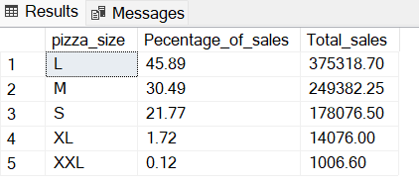

10] Top 5 pizza by Revenue :

select top 5 pizza_name,sum(total_price) as Total_Revenue

from pizza_sales

group by pizza_name

order by Total_Revenue desc

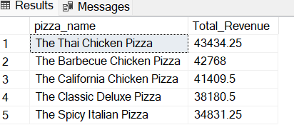

11] Bottom 5 pizza by Revenue :

select top 5 pizza_name,sum(total_price) as Total_Revenue from pizza_sales

group by pizza_name

order by Total_Revenue asc

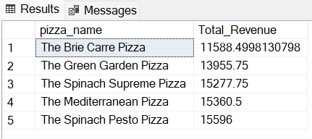

12] Top 5 pizza by quantity :

select top 5 pizza_name,sum(quantity) as Total_Quantity from pizza_sales

group by pizza_name

order by Total_Quantity desc

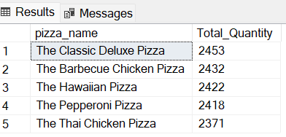

13] Bottom 5 pizza by quantity :

select top 5 pizza_name,sum(quantity) as Total_Quantity

from pizza_sales

group by pizza_name

order by Total_Quantity asc

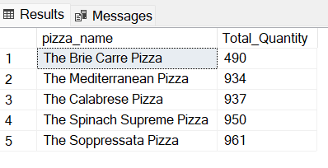

14] Top 5 pizza by orders :

select top 5 pizza_name,count(distinct order_id) as Total_Order

from pizza_sales

group by pizza_name

order by Total_Order desc

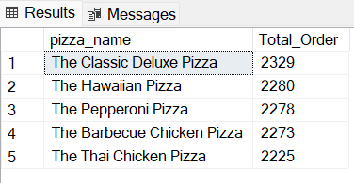

15] Bottom 5 pizza by orders :

select top 5 pizza_name,count(distinct order_id) as Total_Order from pizza_sales

group by pizza_name

order by Total_Order asc

